FOR IMMEDIATE RELEASE
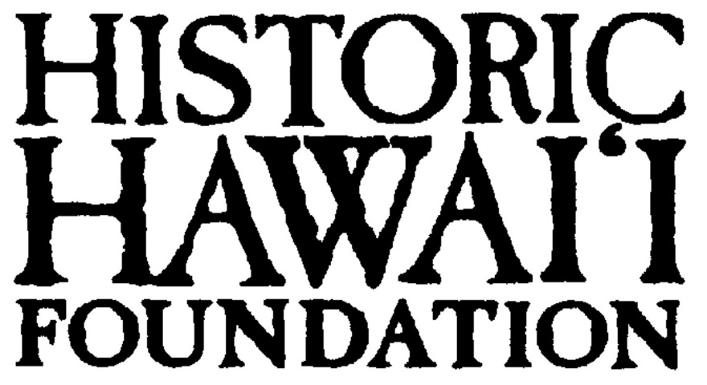
October 21, 2013

CONTACT:
Ms. Andrea Nandoskar
Membership & Communications Coordinator
Historic Hawaii Foundation
808-523-2900
Andrea@historichawaii.org

PAU HANA EVENT TO HIGHLIGHT HAWAI‘I’S MOST ENDANGERED HISTORIC PLACES OF 2013 AND HOW THEY CAN BE SAVED

HONOLULU: Historic Hawai‘i Foundation (HHF) and R&D Inter-island Terminal will present a special pau hana event on Thursday, November 21 headlining Hawai‘i’s 2013 list of the most endangered historic places. The event will be held from 6:00 to 8:00 p.m. at R&D Inter-island Terminal, 691 Auahi Street in Kaka‘ako. The evening will feature informal discussions, a presentation of the 2013 sites and suggestions on how the public can help save them.

The list of endangered historic sites is an annual program of Historic Hawai‘i Foundation. Hawai‘i’s “most endangered” is intended to draw attention to threats to historic places that occur from a variety of sources, including neglect, natural disaster, deliberate demolition and incompatible new development, and to encourage community action to reverse the threats.
“The endangered places list lets community members know about places that are historically significant but that are threatened in some way,” said Kiersten Faulkner, executive director. “We bring attention to these sometimes overlooked or forgotten areas to remind people of their history, how they related to real people and events, and how they shaped and influenced both their generation and contemporary life.”

Wine and light refreshments will be served. Tickets are $5 payable at the door. HHF members who bring a nonmember guest will have their fee waived. Reservations are required and may be made online at www.historichawaii.org. Questions about the event may be directed to Historic Hawai‘i Foundation at 523-2900 or outreach@historichawaii.org

# # # # # # # #

Historic Hawai‘i Foundation (HHF) is a statewide non-profit organization that encourages the
preservation of historic buildings, sites, communities and objects relating to the history of
Hawai‘i. Founded in 1974, Historic Hawai‘i Foundation has become the driving force behind
historic preservation in the state through its core programs of developing a community ethic of
historic preservation, supporting smart legislation, and providing technical assistance to make
preservation accessible. www.historichawaii.org

R&D Inter-island Terminal is a bookshop, exhibit space, coffee bar, project space & idea incubator located in the heart of Kaka'ako whose mission is "presenting international contemporary art, design & film and advancing the role of the arts in innovation". www.interislandterminal.org

